AGENT 2 – LEAD DATA COLLECTION & EMAIL AUTOMATION
Goal
Consolidate and qualify inbound leads every hour.

Flow :
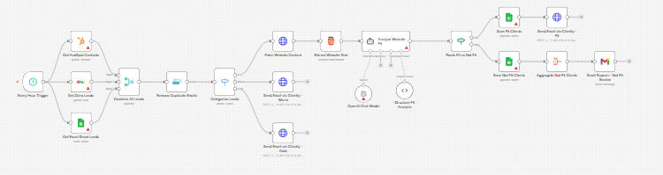
USER STORIES
As Sales Head,
I want leads automatically categorized
So that the team only focuses on high-intent accounts.

WORKFLOW (Hourly Cron)

Step 1: Collect Data
Sources:
- HubSpot API
- Zoho CRM API
- Excel uploads
Merge into:
Master_Lead_Table
Fields:
- Name
- Email
- Company
- Website
- Source
- Timestamp

Step 2: Remove Duplicates
Primary Key:
- Email
If duplicate:
- Keep latest entry

Step 3: Categorization Logic
Category | Rule
Hot | Business email + website exists
Warm | Gmail/Yahoo + no website
Cold | Test / dummy / bot patterns

HOT CATEGORY LOGIC
Step 1: Website AI Analysis
AI Agent visits:
- Homepage
- About page
- Product page
Analyze:
- Is company in travel?
- Does it handle hotels?
- B2B or B2C?
- Tech maturity?
- API mentions?
- Booking engine presence?
Score out of 100.

Step 2: Classification
If Score > 70 → Fit Client
Else → Not Fit Client

Step 3:
Fit Client → Push to Klenty Campaign A
Not Fit Client → Send Excel to Rupesh

WARM CATEGORY
Push to Klenty Campaign B

COLD CATEGORY
Push to Klenty Campaign C

AGENT 2 KPIs
- Fit accuracy %
- Email open rate
- Response rate
- Conversion rate

